MF Utility

API Interface – Electronic PayEezz Registration

JSON API Specification

Version | 1.1
Release Date | 06-Jan-2020
Number of Pages | 10

Document Control

Table of Contents

1 Document Control 2
Table of Contents 2
1.1 Document Information 3
1.2 Revision History 3
1.3 Open Issues 3
1.4 Circulation 3
1.5 References 3
1.6 Definitions, Acronyms and Abbreviations 4
2 Overview 5
3 dependent requirements 5
4 Interfacing Areas 5
4.1 Authentication – Login Service 6
4.2 Authentication – Logout Service 6
4.3 ePayEezz Registration Services – PayEezz Registration & Status 6
4.4 ePayEezz Registration Callback URL (Optional) 7
4.5 API based ePayEezz Registration – Flow 8
5 Model implementation activity & Checklist 8
5.1 API Integration Model Checklist Template - UAT 9
5.2 API Integration Model Checklist Template - Production 9
6 GENERAL SECURITY 10
6.1 Restricted Access 10
6.2 Online Interfaces 10
7 Appendix 10
7.1 APPENDIX A – API Specification for ePayEezz Registration 10

Document Information

Drafted By | Subbulakshmi, Kamalraaj
Reviewed By | Sathiamoorthy N
Client Sources | -
Status | Baseline Version
Version | 1
Release Date | 06-Jan-2020
SoW Reference

Revision History

Date | Version | Description
06-Jan-2020 | 1.0 | Initial Baseline version
16-Oct-2020 | 1.1 | In ePayEezz Registration Mode changes. Added Debit Card

Open Issues

# | Description | Date | Owner | Status

Circulation

MF Utilities India Ltd. And API Entities | Any entities partnering with MFU for API interface.
Intellect Design Arena Ltd

References

N/A

Definitions, Acronyms and Abbreviations

AMC | Asset Management Company
API | Application Programming Interface
ARN | AMFI Registration Number
CAN | Common Account Number. This is a unique number allotted by MFU system for an “Investor combination” which can be used for investments across various Mutual Funds in the industry, when transacted through MFU
Distributors | Distributors are entities who act as intermediaries between the investors and the Mutual Funds. They are empanelled by AMCs to mobilize funds for their schemes. Distributors can also use MFU system to route transactions of investors
ePayEezz | Refers to Electronic PayEezz. PayEezz refers to payment (debit) mandate given by CAN Holder (investor).
MFU | Mutual Funds Utility (MF Utility)
PAN | Permanent Account Number
RIA | SEBI Registered Investment Advisors
RTA | Registrar & Transfer Agents

Overview

- MF Utility (MFU) is a transaction aggregation portal for the Mutual Funds Industry in India, setup under the aegis of AMFI through which the investors may place orders either by themselves or through a Distributor, RIA or an AMC branch or a Point of Service (POS), appointed by MFU.
- PayEezz is a facility offered by MFU under which an investor can register a payment mandate ONE-TIME through which the investor provides a standing instruction to his banker authorizing MF Utility to debit his account for any future subscription transactions (Lump sum or SIP).
- By registering under PayEezz, investors need not issue cheque or other payment instructions every time they make an investment through MFU up to the amount mentioned in the PayEezz mandate. This brings ease and convenience in subscribing for mutual fund units through MFU. This will also enable you to transact paperless.
- PayEezz may be registered for a CAN through physical form, Online interface or electronically using API interface provided by MFU. ePayEezz Registration API Service by MFU is an Net Banking based functionality, accordingly having net banking facility with the Bank mapped in CAN is mandatory for ePayEezz registration through API
- This document explains the API specification that may be used by Partner Entities to submit PayEezz registration detail for their clients electronically to MFU system. This will help the MFU’s partner entity who has their system to collect data may submit the PayEezz registration online to MFU system. This is similar to eCAN Facility where an MFU’s partner entity may register a CAN for their investor(s) with MFU through system interface.

dependent requirements
- Interfacing Entity to complete all the formalities with MFU like agreements process to make use of API Facilities.
- Interfacing Entity to provide all required inputs for setting up this feature.
- Interfacing Entity has their own arrangement to collect the CAN / PayEezz Registration detail and submit the detail online to MFU for further processing. This includes all necessary approval process as per compliance to be in place in interfacing entity system. MFU will treat the registration as approved and process.
- Interfacing Entity to have their own / contracted technical team to implement the API Specification shared by MFU

Interfacing Areas
Following areas have been identified for JSON API based Transaction Interface
Spec Points | Interface | Description
4.1 | Authentication | - Login Service  - Logout Service
4.2 | ePayEezz Registration | - ePayEezz Registration Service  - ePayEezz Status Service

Authentication – Login Service

- Login Request would be the first request from the interfacing application.
- When the interfacing entity is set up in MF Utility (MFU) system, one Symmetric key will be provided for encryption purpose
- Within Login Request, password needs to be encrypted using AES/ECB/PKCS5Padding algorithm.
- Upon successful login, session context and the Transaction Sender User code (Sender User ID) will be returned. This sender user id will be provided with all subsequent transaction requests
- There are success response & error response JSON structure, separately shared in the structure specification in Appendix A.
- If the Login Response is 0, Login Request is successful. The response structure should be read using the success response JSON Object
- If the Login Response is non-Zero, Login Request is failed. The response structure should be read using the failure response JSON Object
- Refer to Authentication-Login Worksheet of JSON_API_Specification in Appendix

Authentication – Logout Service

- Logout Request will be the last request for the session where the interfacing application disconnects from MF Utility Application
- For the Logout request, Session context and Sender User information should be provided.
- System will validate whether the given user is already logged in and if so, it will logs out the user (upon proper session validation)
- If the Logout Response is 0, Logout Request is successful. The response structure should be read using the success response JSON Object
- If the Logout Response is non-zero, Logout Request is failed. The response structure should be read using the failure response JSON Object
- Refer to Authentication-Logout Worksheet of JSON_API_Specification in Appendix A.

ePayEezz Registration Services – PayEezz Registration & Status
- ePayEezz Registration Service is applicable for all empanelled MFU entities who are opting to provide PayEezz registration services to their clients
- For registering the PayEezz electronically using API, there is separate API structure required to be implemented by the interfacing entity and the same is provided in the Appendix A.

Spec. Points | Transaction | Remarks | Reference
 | ePayEezz Registration | API Structure for submitting the ePayEezz Registration detail | ePayEezz Registration worksheet of JSON_API_Specification in Appendix A.
 | ePayEezz Status | API structure to request the status of ePayEezz Registration request | ePayEezz Status Service worksheet of JSON_API_Specification in Appendix A.

- For ePayEezz Registration response the JSON String can be converted to JSON object
- JSON response can be checked for presence of respStatus Key.
  - If respStatus is zero, the JSON object can be read for JSON success response format (attached to respective request structure for ePayEezz Registration or Status)
  - If respStatus is not zero,the JSON object can be read for JSON error response format (attached to respective request structure for ePayEezz Registration or Status)

ePayEezz Registration Callback URL (Optional)
- For Entities wanting to take the control back into their portal after completing the ePayEezz Registration, there is an optional facility available as detailed below:

  - Entities may chose to opt for having the control back after Registration completion and following options are there:

    - S : Server to Server response (MFU to Entity Server through HTTP URL)
    - U : UI Redirection to Entity page (Redirecting the user back to entity portal)
    - B : Both (entity wants to have Server to server call as well as get the user back to their portal)
    - N : None (this means entity does not want to have control back after ePayEezz registration completion in MFU page)

  - Callback URL will be same for both Server to Server call and URL redirection call. The only difference is that in server to server call, registration status will be attached as a JSON string in output stream. In case of URL redirection, in the registration page of MFU, there will be status displayed and the user needs to click on the confirmation button. Here, user will then get redirected to Callback URL page with registration response detail passed as a JSON response in Message parameter

  - Sample Callback URL, Server to Server & URL Redirection
      - Both Success and Failure response will be provided as a JSON Object.
      - In case of Server to Server call, this JSON response will be provided as output stream
      - In case of URL redirection, this JSON response will be provided as a Message Parameter
      - JSON Success Response (Sample)
{"epayDet":{"mmrn":"15776614292626DC5014","respCode":"0","respDec":"Your ePayEezz registration has been initiated. It will take about 5 business days for approval. Once approved, you will be communicated through SMS and email","status":"Success"}}

      - JSON Failure Response (Sample)
{"epayDet":{"mmrn":"15776606582629B13C33","respCode":"1","respDec":"No such account","status":"Failure"}}

Parameter | Description
mmrn | MFU Mandate Registration Number
respCode | status of the response. 0 - success. 1 – failure
respDec | Remarks received from Payment Aggregator
status | Status of the ePayEezz Registration. Success or Failure

API based ePayEezz Registration – Flow

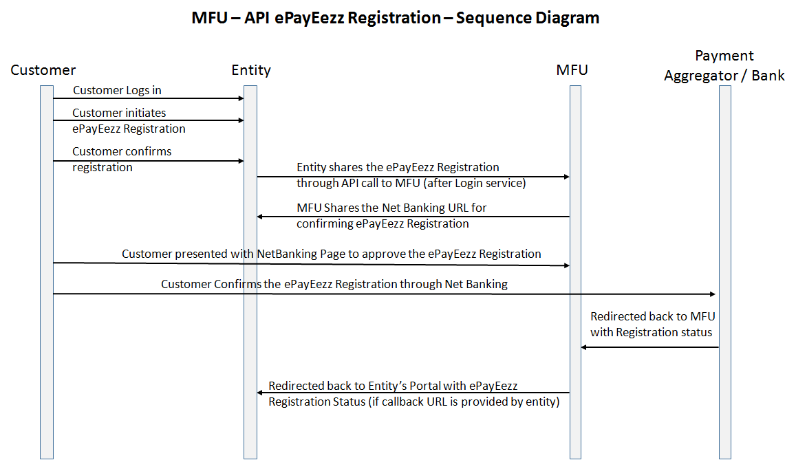

Model implementation activity & Checklist
The Model implementation activities include the following:
Tasks | Action By
Brief walk through on the Specifications | MFU & Entity
Sign-off Agreement with MFU for API Services | Entity & MFU
Entity UAT readiness | Entity
Integration Checklist Sharing with UAT URL & UAT Symmetric Key for interfacing | MFU & Intellect
MFU UAT environment readiness | MFU
Integration testing by customer & Application team | MFU, Intellect & Entity
Go Live Planning | MFU & Intellect
GO Live Support  Support for First week of Live | MFU & Intellect
Further support on Live implementation | MFU

API Integration Model Checklist Template - UAT

Test Environment Details for the Entity API Integration
Description | Remarks | Action By
Entity ID | MFU will Provide the Entity ID upon Entity creation  Sample Value : 41000D | MFU
Entity Name | Name of the Entity | Entity
Login Id | Will be provided during the UAT testing | MFU
Password | Will be provided during the UAT testing | MFU & Intellect
Symmetric key (for password encryption) | Will be provided during the UAT testing | MFU & Intellect
Test Environment URL | Will be provided during the UAT testing | MFU
Test Environment Port | Will be provided during the UAT testing | MFU
Sample URL (For Login) | Will be provided during the UAT testing | Intellect
Contacts for Support / Queries
Business Flow / Operational queries on JSON-API | You may contact authorized SPOC from MFU on any queries or issues pertaining to business flow / operational flow.  Details will be shared to you in checklist during Integration testing | MFU

API Integration Model Checklist Template - Production

Production Environment Details for the Entity API Integration
Description | Remarks | Action By
Entity ID | Will be provided during the Live | MFU
Entity Name | Name of the Entity | Entity
Login Id | Will be provided during the Live | MFU
Password | Will be provided during the Live | MFU & Intellect
Symmetric key (for password encryption) | Will be provided during the Live | MFU & Intellect
Production Environment URL | Will be provided during the Live | MFU
Production Environment Port | NA | MFU
URL Call (For Login) | Will be provided during the Live | MFU
Business Flow / Operational queries on JSON-API | You may contact authorized SPOC from MFU.  Details will be shared to you in checklist during Live | MFU

GENERAL SECURITY

Restricted Access
- Once Agreement is signed, their API access is enabled. Not all the transaction entities have access to this feature.

Online Interfaces

- HTTPS would be used for communicating with the Online Interfaces; It is a network layer encryption and uses SSL
- Symmetric Key will be setup for each interfacing entity and the key should be used to encrypt the password in the login request.
- Session validation is done for each of the transaction initiated through API

Appendix

APPENDIX A – API Specification for ePayEezz Registration

- JSON API Structure along with guideline is appended herewith for the developer reference.
- Worksheet for each of the services is available in the specification.
- URL given against each of the service should be appended to the base URL received for a particular environment from MFU India (UAT Environment, Testing Environment, Production Environment)

